 | 763 Ridge Road  Angier, NC 27501  Tel 919 894 7976  Contact Tim Langdon  Cell 919 412 2155

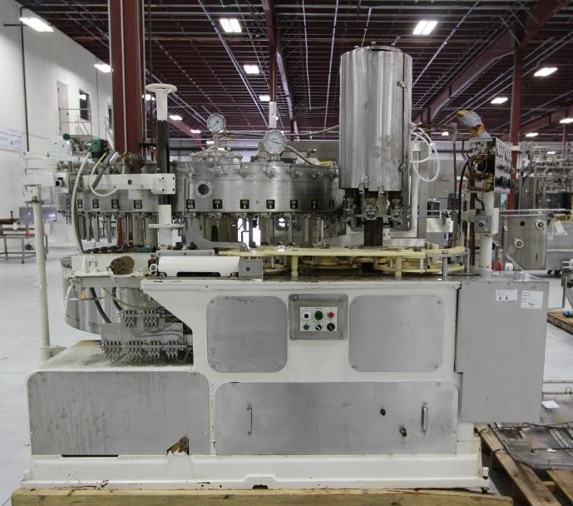 | Crown 45 Valve Filler with Crowner Available  Model Crown Uni-Blend 45-6  Serial # D-45-6-UB-75  Year 2007  Speed 12oz up to 400 bpm  6 Head Crowner  460 V * 60 H * 3 P  Glass Explosion Shields Included  We can build complete Production Line around this filler.  Price to sell … $75,000.00
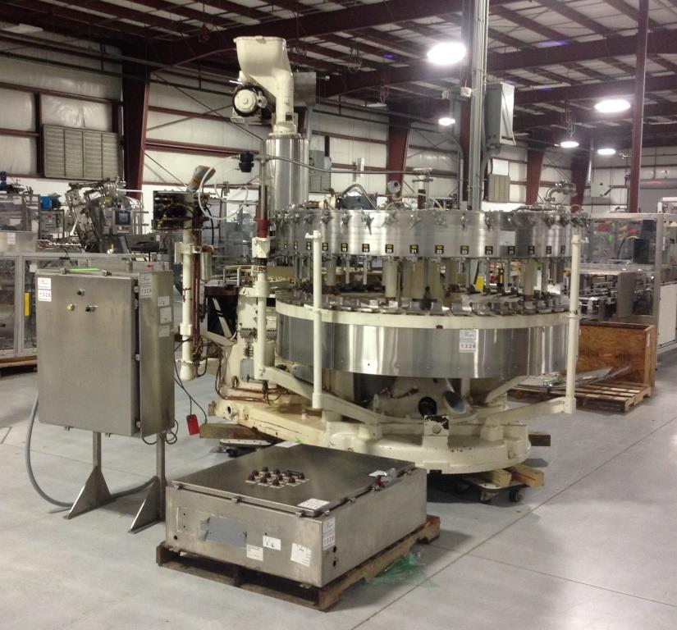 | 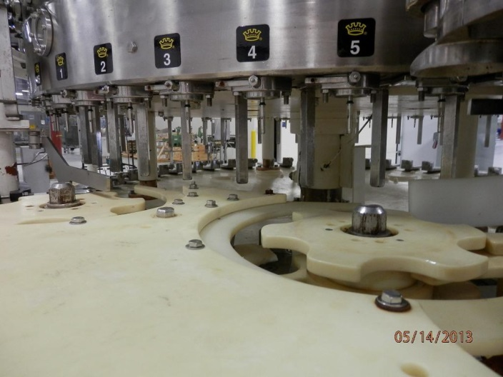
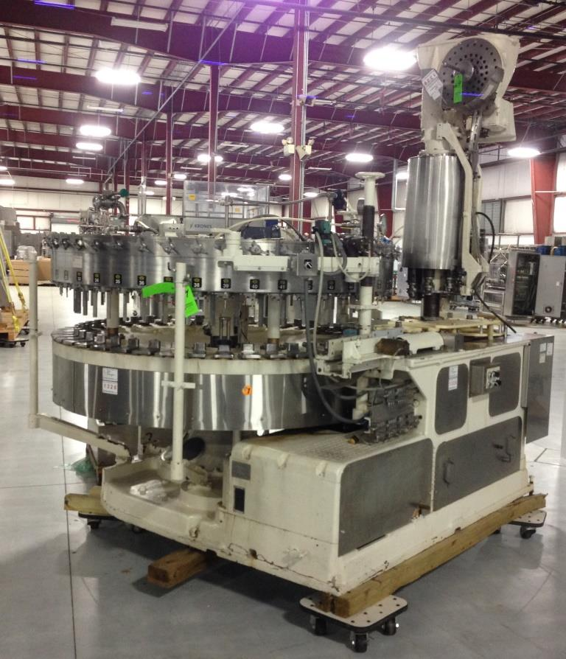 | 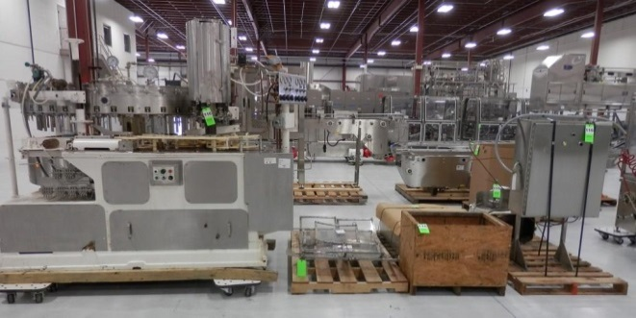  We can Install  919 412 2155 Tim Langdon

