 | 763 Ridge Road  Angier, NC 27501  Tel 919 894 7976  Contact Tim Langdon  Cell 919 412 2155

Crown 60 Valve Filling Line

Item | Description | Model | S/N | Notes | Price
1 | Simplimatic Bulk Depal | 400-2D | 7972 290 635 | 208 V * 3 P * 60 Hz  1990
2 | Ambec Single Filer 55 LF +  Pressureless Combiner | 2002 Year Model |  | All Stainless Steel – LF  With Mezzanine  600 BPM 16oz, 20oz, 24oz
3 | Seco Gripper Rinser |  |  | Lowerator Type
4 | Ailadin Air Conveyor 100 LF + |  | 95-30-9671 | Dual Lane 1995 w/9 blowers
5 | Crown 60-16 Filler | 60-16 Qt | 60QT500 / Yr. 1978 | 4.25” Pitch Quart Filler
6 | 16 Head Alcoa Capper | Series 200 -9221-16 |  | Missing 28mm Heads - 9/12/2011  SV3 Cap Sorter – 28mm 1881 Mini Conversion
7 | CSI Cap Hopper | SV-3 - | 0022 / Yr. 2011 | Like New
8 | Mojonier Carbo Cooler | 6455 |  | Dual Tank - NATL BD # 7454  Yr. 1960/Refurbished 1998  Syrup Recovery Update 1998
9 | DJI Blender * Flo Mix | Q |  | All Stainless Steel - 1987
10 | Filler Control Panel
11 | Control Panel FloMix / Carbo Cooler
12 | Filler / Capper Control Parts | .500 ml
13 | Filler / Capper Control Parts | 20 oz
14 | Filler / capper Control Parts | 24 oz
15 | Filler Bottle Control Parts | Same
16 | CIP Manifold for Filler
17 | Filler Discharge Conveyors | SS |  | Electric Drive
18 | Dual 7.5” Bottle Conveyors | SS |  | Hydraulic Drive
19 | BFT Bottle Warmer | 8 x 24 | J 0186 – YR 1988 | Hydraulic Drive  Series 100 Raised Rib Matt
20 | BFT Accumulation Table | 8 x 24 | J 0186 – YR 1988 | Hydraulic Drive
21 | Hartness Continuous Motion Packer with Heads | 2600 | 26008 | 1991
22 | Case Conveyors | Hytrol
23 | Tray Depal |  |  | Manual Operator Station
24 | Nigrelli Tray Denester | Denester | DN 96 1579 60 | 1996
25 | Spare Parts for Line |  |  | No Pictures
26 | Manuals for above |  |  | No Pictures
27 | Heavy Duty Mezzanine & Stairs
28

Contact Tim Langdon @ 919 412 2155 Cell Email timonthyl@aol.com

Pictures related to Crown 60 Line

Item | Picture | Item | Picture | Item | Picture
1 Depal | 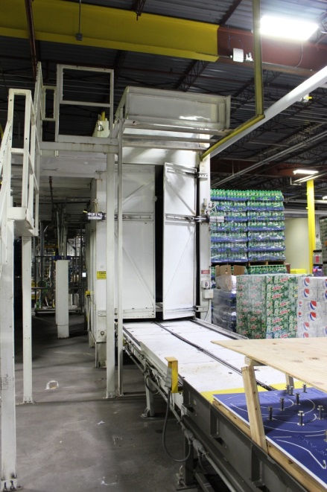 | 2 Single Filer | 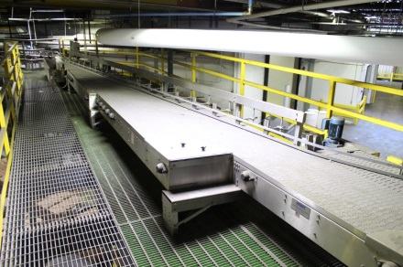 | 3 Gripper Rinser | 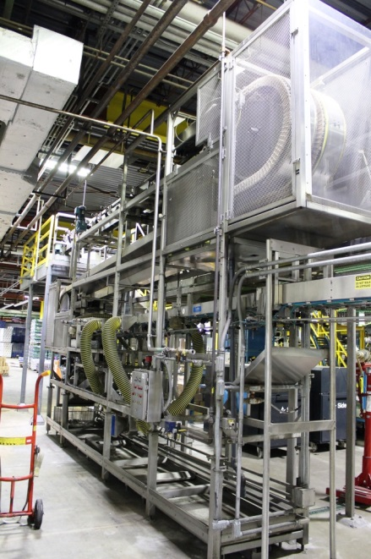
4 Air Conveyor | 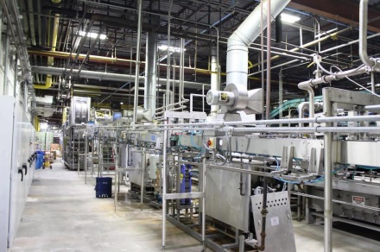 | 5 Crown 60 Filler | 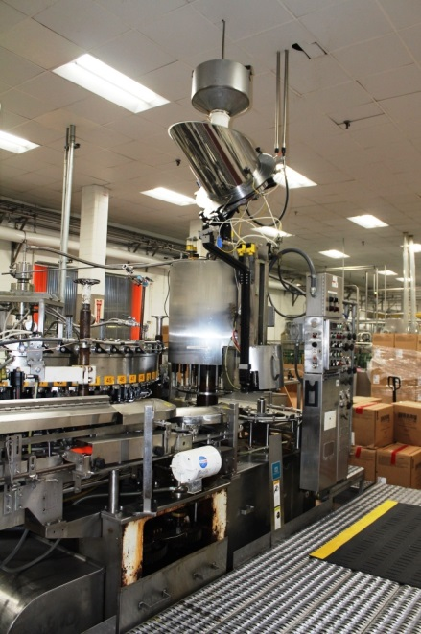 | 6 Capper | 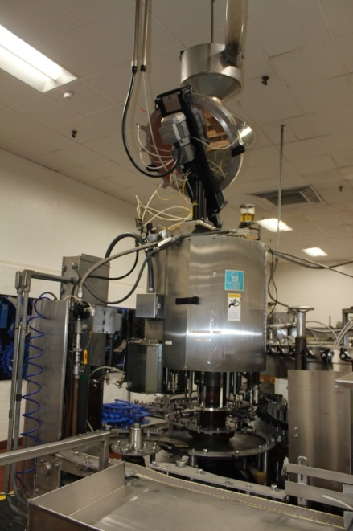

Pictures related to Crown 60 Line

7 Cap Hopper | 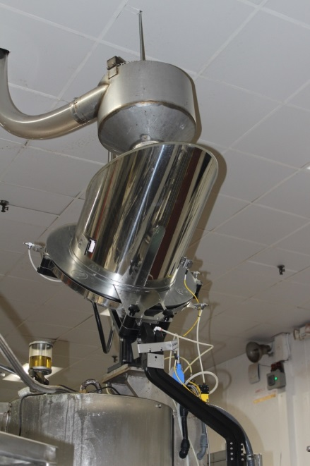 | 8 Carbo Cooler | 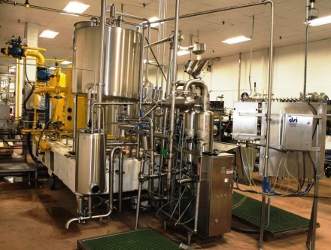 | 9 Blender | 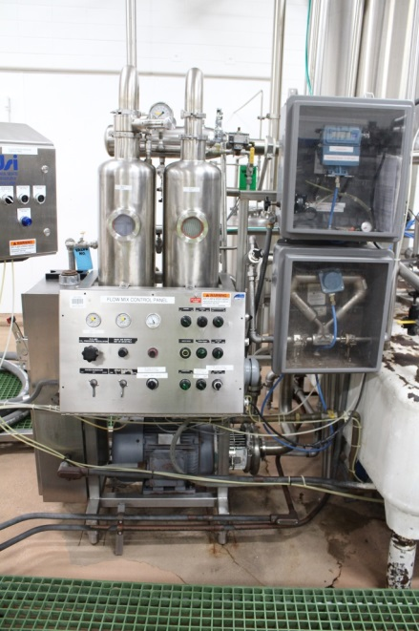
10 Filler Control Panel | 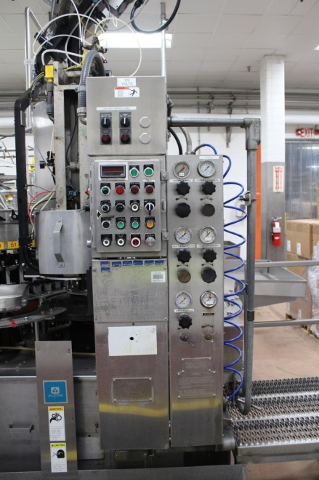 | 11 FloMix Control Panel |  | 12 .500 ml Control Parts | 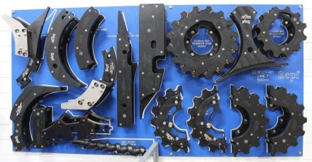

Pictures related to Crown 60 Line

13 20oz Control Parts | 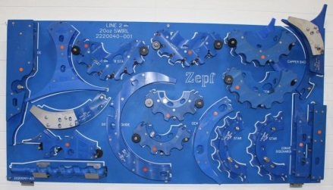 | 14 24oz Control Parts | 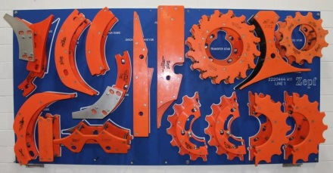 | 15 Filler Control Parts | 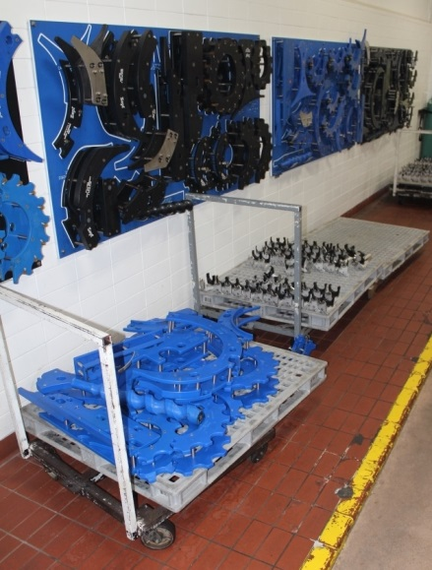
15 Filler Control Parts | 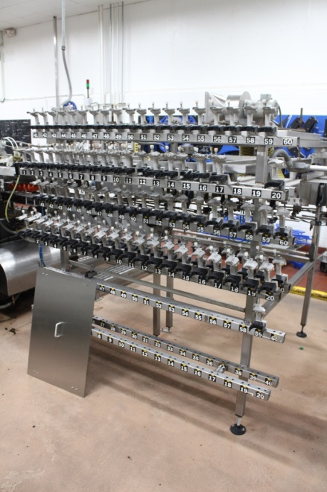 | 16 CIP Manifold Filler | 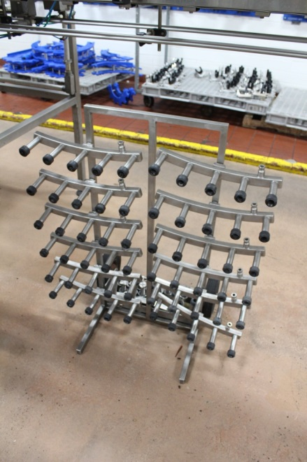 | 17 Filler Infeed & Discharge | 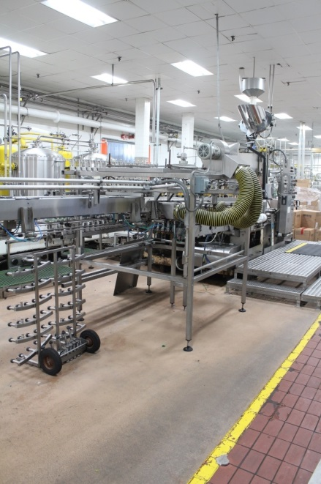

Pictures related to Crown 60 Line

18 Dual 7.5” Conveyors | 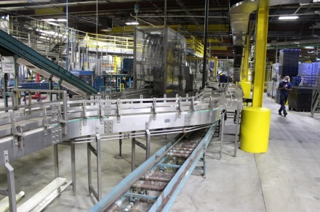 | 19 8x24 Bottle Warmer | 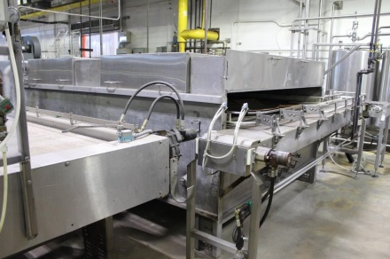 | 20 8x24 Accumulation Table | 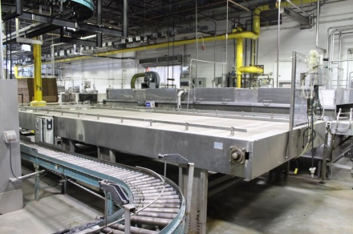
21 Hartness Packer | 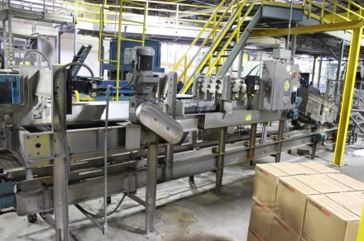 | 22 Case Conveyors | 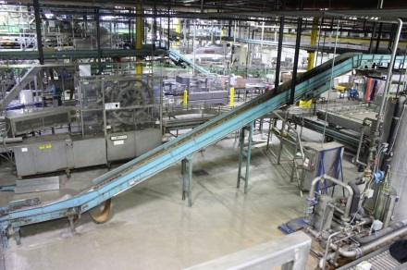 | 23 Tray Depal | 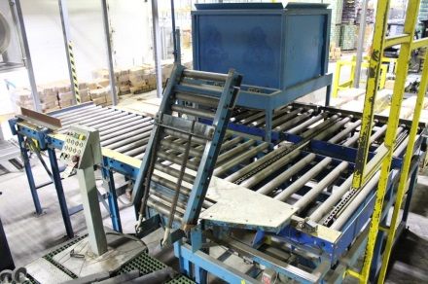
24 Denester | 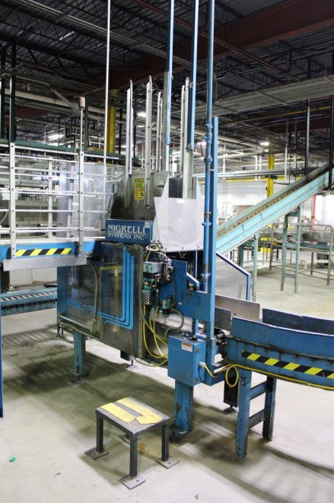 | 25 Spare Parts | No Picture | 26 Manuals | No Picture

Pictures related to Crown 60 Line

27 Mezzanine | 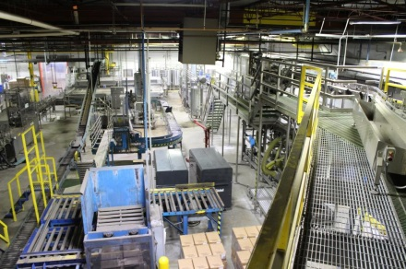 | 28 Labeler | Available Option | 29 Palletizer | Available Option
30 Solution Heater | Available Option | 31 Hydraulic Pump | Available Option | 32 Box Maker | Available Option

Pictures related to Crown 60 Line

Filler Room | 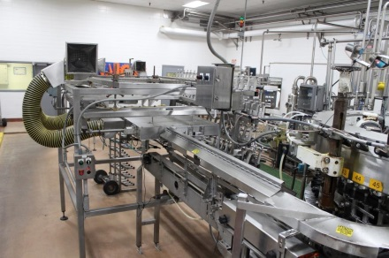 | Filler Room | 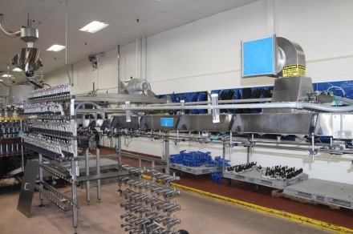 | Filler Room | 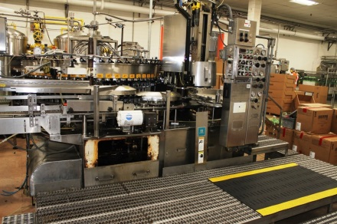
Filler Room | 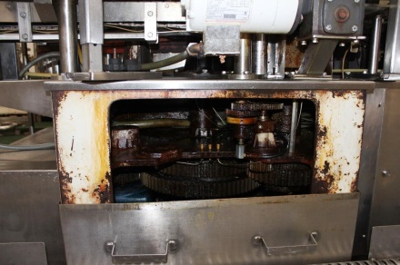 | Filler Room | 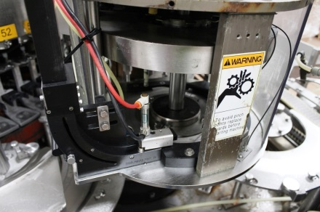 | Filler Room | 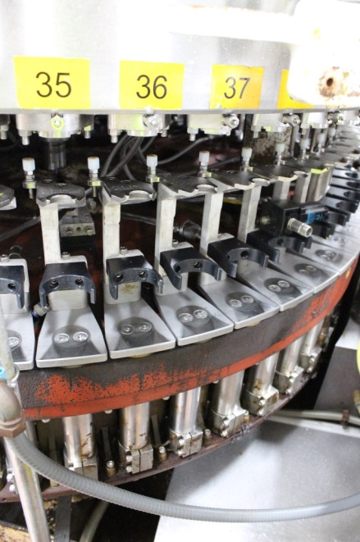
Filler Room | 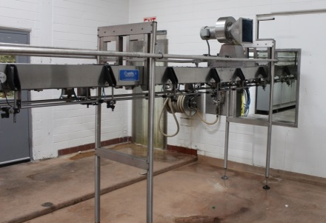 | Filler Room | 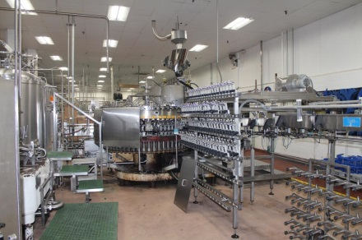 | Filler Room | 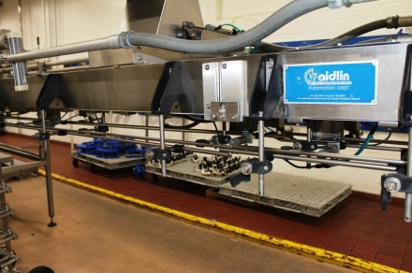

Pictures related to Crown 60 Line

Plant Overview | 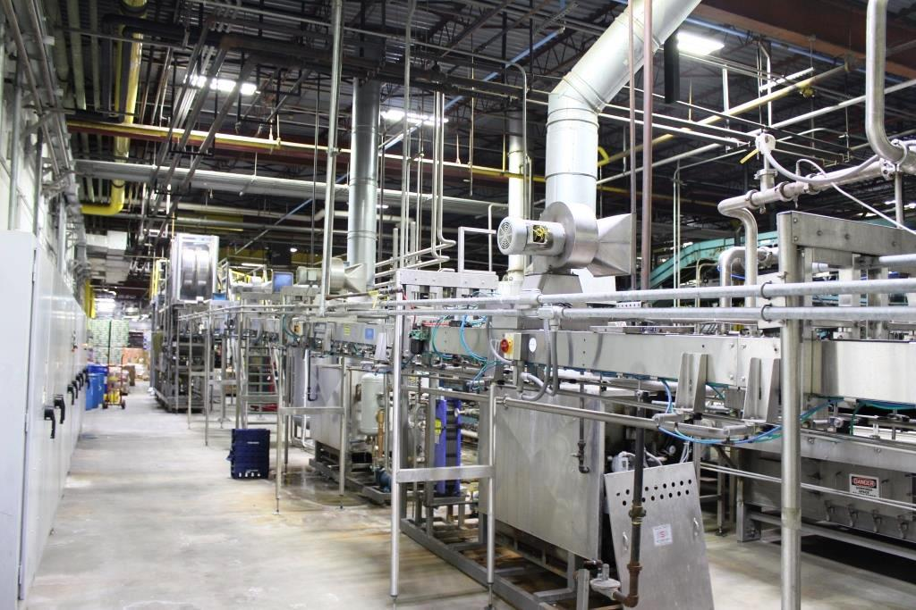 | Plant Overview | 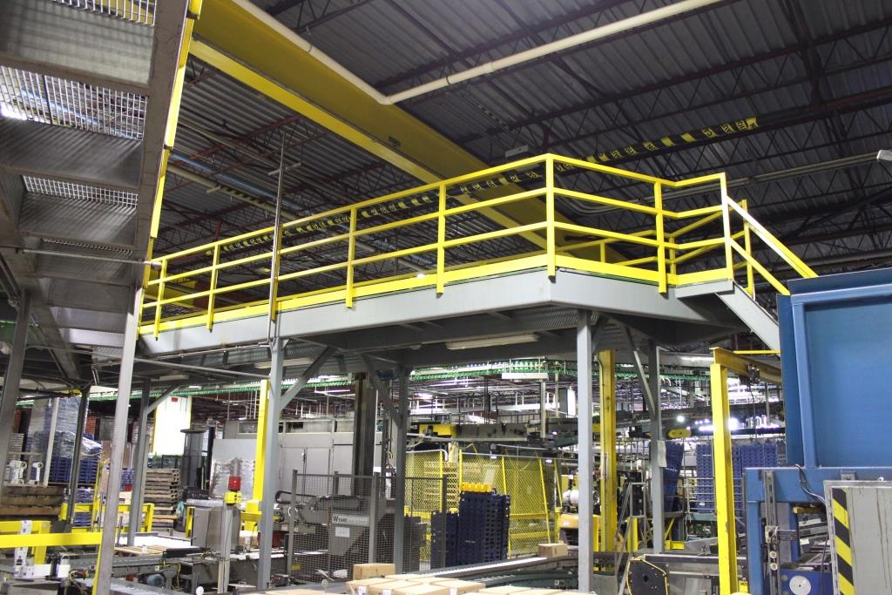
Plant Overview | 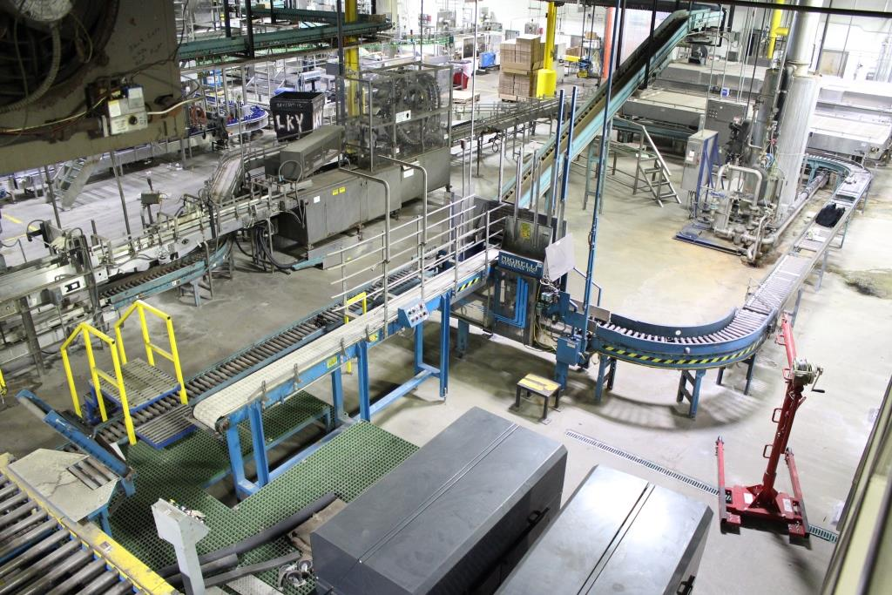 | Plant Overview | 