Cardinal Bevack LLC 763 Ridge Road Angier, NC 27501 Tel 919 894 7976
Surplus Beverage Production Assets Removal Date January 2015 Page 1 of 2

1 – Faunc Robotic Arm: Item # 072515-05 $ 4,500.00
Pick and Place Robotic Arm with Controls Or Best Offer

Model A-520i w/ R-30iB Controls S/N 0217 MFG 2005
Electrical Requirements: Footprint:

1 – Fraunc Robotic Arm: Item # 072515-06 $ 4,500.00
Pick and Place Robotic Arm with Controls Or Best Offer

Model A-520i w/ R-30iB Controls S/N 0218 MFG 2005
Electrical Requirements: Footprint:

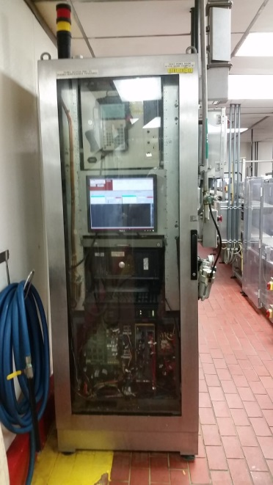 | 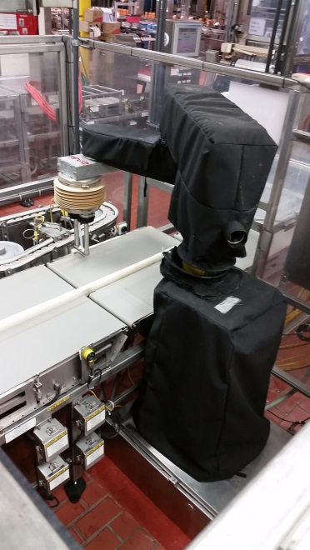
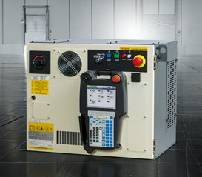 | R-30iB controller for FANUC robots  - Compact and stackable  - Extra smart iPendant Touch  - Maximised energy saving  - Enhanced productivity  - Faunc Controller Product Page  - Click Here for FaceBook Video  Notes: Robotic Arm Controls will be removed from cabinet pictured above. Plant plans on reusing Control Cabinet.  We can Quote a Stainless Steel Control Cabinet for an additional Charge.

Info: Contact Tim Langdon @ 919 412 2155 cell & Tim@CardinalBevpack.com

