 | 763 Ridge Road  Angier, NC 27501  Tel 919 894 7976  Contact Tim Langdon  Cell 919 412 2155

Surplus Beverage Production Assets Removal Date December 2015

SWF – McDowell Case Erector with Nordson Pro Blue 10 Glue Units

Mach. Footprint: 8’ L x 7’-8”’ W x 6’ H
Skid Footprint: 8’ L x 7’-10” W x 6’-6” H
Weight: 2,000 LBS (+-)
Electrical: 230 V
Speed: Up to 30 CPM.
Case Range: 5-3/4" to 24" in L; 5-3/4" to 24" in W; 10" to 33" H
1 – SWF McDowell 201 RH Box Erector: $25,500.00
With Nordson Pro Blue 10 Glue Units SOLD
Item # BoxErec-15008 Model 201 RH S/N

1 – SWF McDowell 201 RH Box Erector: $22,500.00
With Nordson Pro Blue 10 Glue Unit Or Best Offer
Item # BoxErec-15009 Model 201 RH S/N

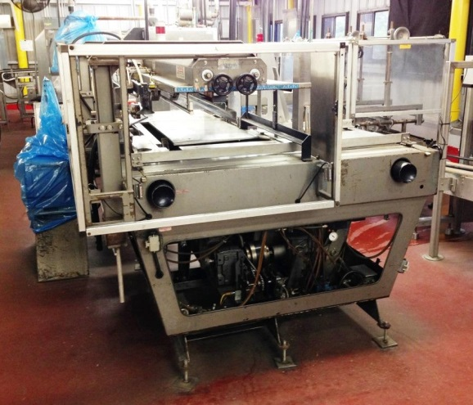 | 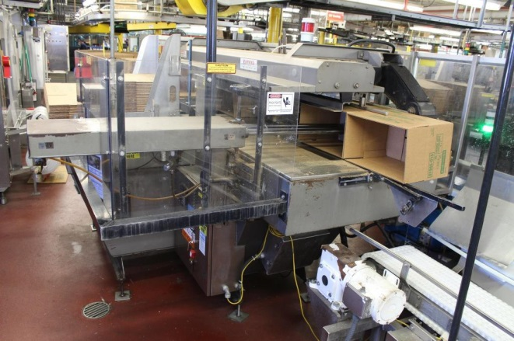
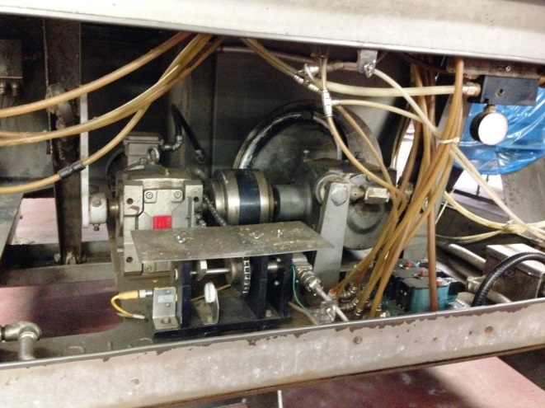 | 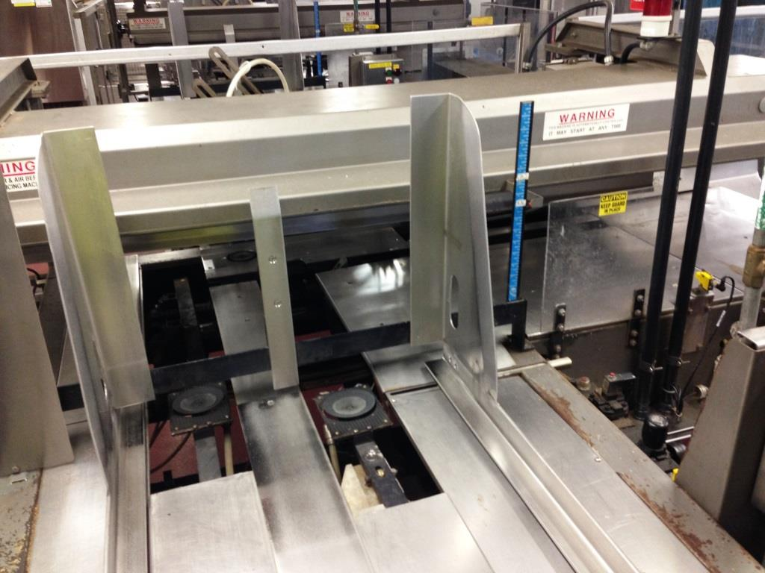
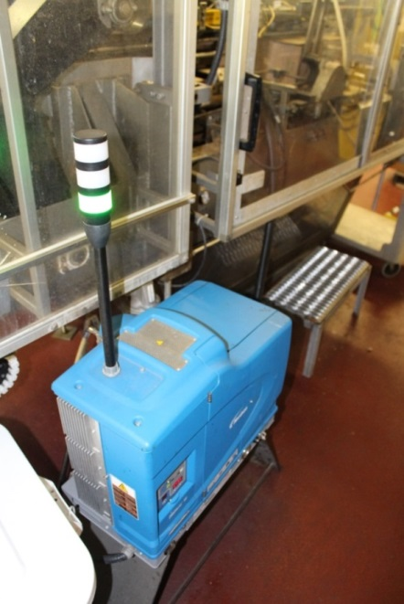 | 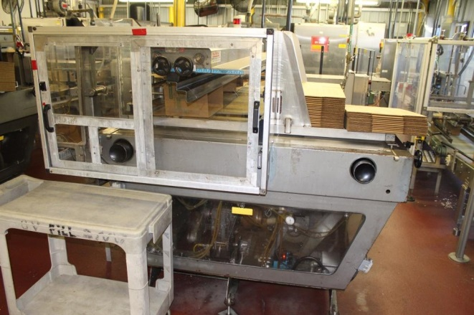  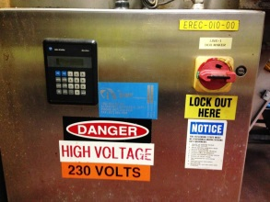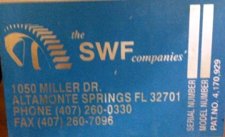
Contact Tim Langdon @ Cell 919 412 2155 * Email Tim@CardinalBevpack.com | Formerly Designated McDowell Case Erector  Video Available On Request and on  www.facebook.com/CardinalBevPack/

