|  |  |
| --- | --- |
|  | ***763 Ridge Road***  ***Angier, NC 27501***  ***Tel 919 894 7976***  ***Contact Tim Langdon***  ***Cell 919 412 2155*** |

***Sidel Blow Mold Parts Carts***

**Type # 1 (1) @ $5,500.00 each**

Each unit uses an aluminum frame, rotates on that frame. Can be rolled into place or picked up and moved with a lift. The cabinet lifts upwards as shown.

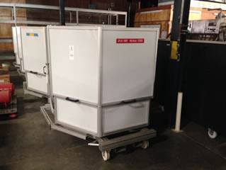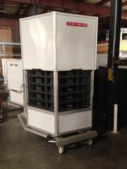

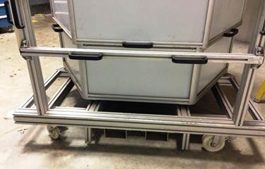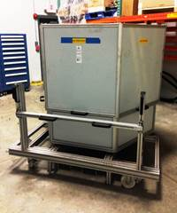

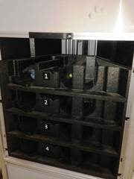 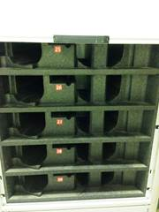 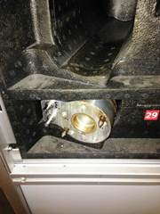

|  |  |
| --- | --- |
|  | ***763 Ridge Road***  ***Angier, NC 27501***  ***Tel 919 894 7976***  ***Contact Tim Langdon***  ***Cell 919 412 2155*** |

***Sidel Blow Mold Parts Carts***

**Type # 2 (1) @ $2,200.00 each**

Each unit uses a pallet jack type roller platform and will rotate and lock into position.

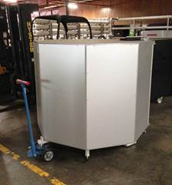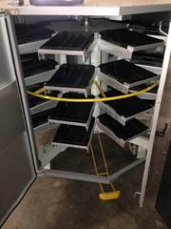

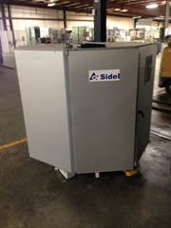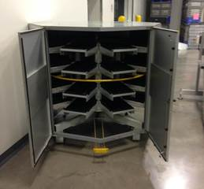

|  |  |
| --- | --- |
|  | ***763 Ridge Road***  ***Angier, NC 27501***  ***Tel 919 894 7976***  ***Contact Tim Langdon***  ***Cell 919 412 2155*** |

***Sidel Blow Mold Parts Carts***

**Type # 3 (6) @ $3,750.00 each**

Each unit has three parts shelves and a lower storage area below the shelves. The tops open on both sides.

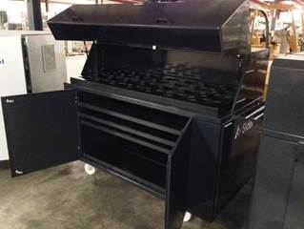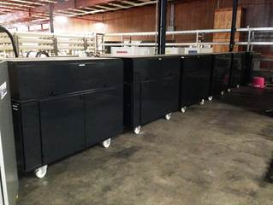

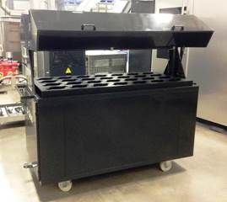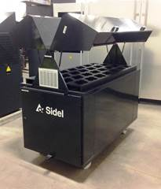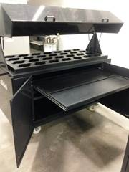

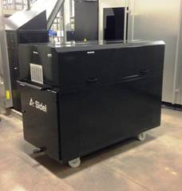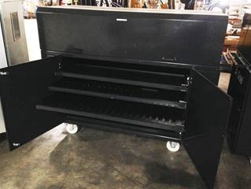

Tim Langdon [Tim@CardinalBevPack.com](mailto:Tim@CardinalBevPack.com)

919 412 2155 Cell * 919 894 7976 Office